# CHAPTER ONE INTRODUCTION

## **Background of Study**

Looking back at the start of the Digital Age, nobody would have predicted that the introduction of the World Wide Web would progress as swiftly as it did. It has successfully transitioned the daily lives of individuals from across the globe from businesses down to their daily activities.

And in the recent global outbreak of Covid-19, which has forced almost everyone to go into quarantine and isolation in order to control the widespread of the pandemic. This situation has affected the daily lives of all individuals as well as businesses in all economic sectors, forcing them to adapt to the changes in their daily lives. All forms of communication, celebratory events, work-related task and all other activities that were once considered a norm, were forced to be digitalized and be conducted in a different medium.

Economic sectors that have failed to transition their businesses online have suffered from major financial difficulties, which spans from a loss of company income down to relieving individuals from their job position. Conversely, for those who did manage to adapt and change their business models to be integrated into online platforms have managed to save themselves from this global pandemic and at the same time, certain business organization have also profited greatly from it. For one, it can be observed that online shopping platforms, logistic centres and delivery services are among the businesses that have increased in popularity because of this incident.

Moving back to the industry that the application to be developed is targeted on, which is the property market industry. As one would expect, the property prices in the market have indeed plummeted slightly, which causes a worry for tenants and landlords on whether to sell their current property on hand. Having a low market price is one thing, but the number of active clients who are in search of a property to buy or rent is also another factor.

Furthermore, since majority of the construction works also had to be delayed, property developers would also have to revise their schedule and budget, which would delay the launch of their respective projects. Although online marketing during this period can be more effective than it was before, but the aspect of clients not being able to view the properties also had to be considered by both the real estate agents and developers. This is due to the fact that clients would usually prefer to view their preferred property in person before attempting to make a purchase, which is restricted due to the pandemic. There are currently many property listing applications available in the market that could offer a platform for agents and developer to list their properties for sale, as well as for client to browse through the list of properties. However, majority of the applications only offers general features, which could be improved by implementing some of the newer technologies in the market, which will be explained in detailed in the following sections of the report.

## **Statement of the Problem**

According to the answers provided by a former property development manager in a recent interview session, several problems were highlighted regarding the current state of the property market, which is beneficial in providing insights in this research. The problems were analysed and listed as shown below.

### **Lack of Virtual Visualization Features for Home Viewing**

Traditionally, clients would use the photos uploaded to the respective property’s listing as a first impression when considering to rent or purchase a particular property. These would act as a baseline before scheduling for a site visit to the actual property itself. However, due to the circumstances of clients not being able to view the properties in person, a more convincing and realistic experience has to be provided in order to attract the interest of the potential homebuyers.

### **Ineffective Booking Features When Purchasing Properties**

The property market applications that are currently available in the market does not have a proper tracking system to monitor each stage of communication between the customers. In general, these applications were only used as a platform for agents and property developers to market their projects and currently available properties to be advertised to the public.

### **Difficulties in Reaching out to Real Estate Agents**

Baryla and Ztanpano (2020) highlighted that homebuyers spend a longer time searching for a property on their own compared to those that hired a real estate agent to assist them in doing so. The above statistics is true for all types of homebuyers, regardless on whether they are new, experienced or an out-of-town buyer.

## **Aim and Objectives of the Study**

The main aim that this project aims to achieve is “To develop and implement a mobile based property market application”. However, the main objective can be broken down further into sub-objectives which could be considered as the milestones for this project. The sub- objectives are as listed below

The objectives are:

1. An engaging and easy to use UI with good UX using React.js.
2. The logic will be handled using Node.js and the data will be stored using Firebase.
3. Evaluating and verifying the app.

## **Scope of the Project**

Within this section, the project scope was categorized into targeted users in which the property listing application aims to serve, along with both the covered and uncovered modules that was integrated as part of this project.

### **Targeted Users**

1. Tenants who are looking to purchase or rent a real estate property.
2. Real estate agents.
3. Administrators.

### **Modules Covered**

1. Registration and login
2. First time users should be able to register a new account in order to utilize the full features of the application.
3. Existing users shall be able to login into their previously created account.
4. Searching for properties and units
5. Users shall be able to search for a property or unit by typing in the location through text within the search bar provided.
6. Users shall be able to search for a property or unit by specifying the location in the GoogleMaps provided, which would then display the search results within the radius of the coordinates specified.
7. Display search results
8. Users shall be able to view their search results in a traditional structured list format.
9. Users shall be able to view their search results on the GoogleMaps itself by pop-ups on the same screen after specifying the coordinates of their desired property or unit.
10. Integrated chat feature
11. Tenants shall be able to utilize the integrated chat feature to contact real estate agents to enquire about the listings that they are interested in.
12. Real estate agents shall be able to utilize the integrated chat feature to respond to their client’s enquiries.
13. List properties for sale or rent
14. Real estate agents shall be able to list their available properties and units up for sale or rent on the application.
15. Favourite selected properties
16. Tenants shall be able to favourite their selected properties which allows them to revisit those listings easier in the future.
17. Schedule and manage viewing appointments
18. Tenants shall be able to schedule appointments with real estate agents in charge of the preferred listing in order to view that particular property or unit.
19. Real estate agents shall be allowed to view the list of appointments scheduled with their respective clients through the application.
20. Display details of a selected listing
21. Details regarding each listing includes static photos, panoramic photos, location, price, size per square feet, number of bedrooms and bathrooms, property type, listing type, furnishing condition, unit features, description and nearby amenities.
22. Real estate agents shall be able to provide detailed description regarding their respective listings and projects on the application.
23. Tenants shall be able to view the detailed description provided by the handlers of the respective listing that they are interested in.
24. Search for real estate agent services
25. Tenants shall be allowed to search for real estate agents on the application to help facilitate them in accomplishing their process of purchasing or renting a property.
26. Upload and access important documents
27. Users shall be allowed to upload documents through the application within the application itself.
28. Add new real estate agents
29. Administrators are allowed to register new real estate agents which enables them to publish new property listings on the application.

## **Limitation of the Study**

Due to the limitations set by time constraints, certain modules will not be covered and implemented into application in order to be able to deliver the system on time. The modules that would not be covered are listed below.

### **Integrated payment features**

Although there is potential for payment services to be implemented into real estate applications to facilitate the initial procedures of purchasing a property, such as booking fees and down payments. There is a significant risk that is associated with it in which clients might be hesitant to make payments of large sums through the application. However, the overall features of the application would not be affected even though any form of payment shall be done in external platforms.

### **Chatbot assistance**

It is understood that many platforms and applications have their own integrated chatbot assistance that could provide immediate responses to clients regarding their enquiries, such as frequently asked questions (FAQs). However, due to time constraints, an effective and accurate artificial intelligence may not be able to be programmed on time to meet the submission deadline. Thus, this feature was omitted from the development process.

### **Virtual and augmented reality visualization features**

Technological advancements have allowed applications to be equipped with virtual and augmented reality features to improve their user’s experience. However, there are still areas in these newer technologies that have yet to be explored and solidified through research. Additional time and effort are required to study on how these features can be implemented into the real estate application and thus, these visualization features will be excluded from this project.

### **Rating and feedback for real estate agents**

Due to the large scope that has been set in this project, including more features to be implemented might risk them not being able to meet the scheduled deadline. Therefore, features that allow clients and tenants to leave reviews and feedbacks to the real estate agents that has assisted them in the past have been excluded from this project.

## **Significance of the Study**

The platform or web app stands to benefit the Realtor Market to share property on sale or for rent.

## **Project Organization**

The project is made up of three chapters. Chapter one summarizes the introductory study on Real Estate app, including the background of study, statement of the problem, aim and objectives, significance of the study, scope of the study and limitation of the study. Chapter Two is the review of related literature. Chapter three is proposed methodology.

# CHAPTER TWO LITERATURE REVIEW



## **Introduction**

A look at what the programming language and database used the project are and a review of related literature.

## **Related Literature**

As mentioned in the earlier parts of this report, there are currently several similar applications that are currently available in the market today. In this chapter, five applications with similar features and functionalities in the property domain is selected and analysed in detailed.

For each application, the key features will be highlighted along with a detailed evaluation of the overall application, in which a breakdown between the pros and cons of each application will be emphasized. This includes the application's design, features and the overall user experience that it offers. At the end of this section, the essential features of the application to be developed will be highlighted along with some additional features in which the application can be improved to offer a wider and more complete application its targeted users.

### **Analyse Similar Mobile Applications**

Two applications with similar features and functionalities within the property domain was selected to be analysed in detail within this section of the report. This process was done in order to facilitate the requirements definition process, whereby essential features that the project should contain was extracted. Furthermore, loopholes and potential enhancements that could be made to improve the existing property listing applications was also analysed in order to implement the enhancements within this project.

#### **EdgeProp**

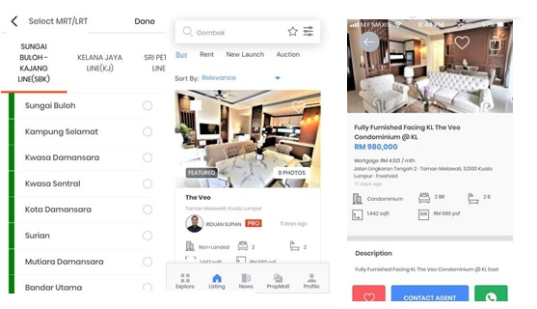

Figure 2.1: Screens Of EdgeProp’s Mobile Application

##### Main Features of EdgeProp

**Search By MRT**

Instead of having a just general search by text feature to allow users to search for a particular location, EdgeProp’s application provides a selection list that contains the names of MRT stations. Users could select the MRT station of their choice and the application would display the search results of the properties which are close the selected station. This feature eliminates the need for users to enter the names of the MRT stations manually in order to search.

**Search by Area**

Similar to the selection list feature for searching by MRT, EdgeProp’s application also provides a similar feature which allows users to search for properties by area. For example, should users wish to view all the available properties to buy and rent in Balakong, they could utilize this feature by first selecting the state of the district followed by the district itself. In this case, users would have to click on Selangor from the selection list, followed by Balakong immediately after that.

**Provide Updates To Latest Property News**

EdgeProp also provides a feature that integrates the latest property news into the application to allow users to read through and stay up to date with the latest occurrences in the property industry.

**Features Latest Property Developer’s Projects**

Instead of focusing on the attributes of real estate agents, EdgeProp’s application also provides a feature that allows property developers who are interested to advertise their latest projects in the application. In each detailed project listing, information such as the description of the project, company background, project location, features of each unit, floorplans and key amenities situated close to the project location will be provided. In addition, should users be interested to know more about a particular project, they could fill in an enquiry form so that the company involved could reach out to them in return.

#### **PropertyGuru**

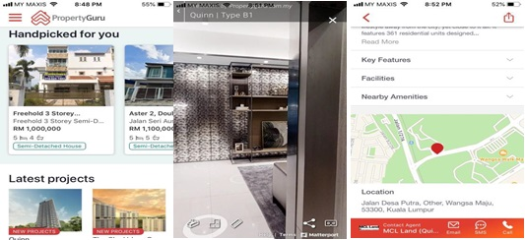

**Figure 2.2: Screens of PropertyGuru’s Mobile Application**

##### **Main Features of PropertyGuru**

**Select By Location On GoogleMap**

PropertyGuru’s application provides an additional search feature in addition to the general searching through text. Users are able to utilize the integrated GoogleMap provided within the application and pinpoint a particular coordinate in which they would like to search properties at. The property listings relative to the location of the search result will be displayed shortly after.

**Display Search Results On GoogleMap**

Instead of displaying the search results in a list format similar to what most application have done. PropertyGuru’s application also provides a different style of presenting the location of each property, which is through coordinates on the integrated GoogleMap. Upon clicking on one of the pop up locations on the map, more detailed information can be viewed regarding the selected property.

**Provide Suggestions For "Similar Properties"**

Property Guru’s application considers the past search results that users have made and provides suggestions on properties with features similar to it. This feature reduces the need for users to search for properties that contains features similar to the ones that they are currently looking for. Users are able to browse through the featured listings handpicked by the application itself.

**Features Latest Property Developer’s Projects**

Similar to what has been mentioned in EdgeProp’s application in the previous section of this report, this application also provides a platform for developers to advertise and market their projects.

**Find Agents For Specialized Services**

PropertyGuru’s application also provides a feature that allows users to search for qualified real estate agents to assist them in their required services. Users will be able to select the agent of their choice, view the background information provided by them and contact them if the users are interested. Agents are categorized and grouped into several categories, which includes the monthly featured agents, landed property specialized agents, commercial featured agents and many more categories that are offered.

**Offers Virtual Tour For Specific Property Listings**

PropertyGuru’s mobile application offers virtual tour features for selected properties. Instead of using the traditional approach of only providing static photos of the property to the potential homebuyers, property developers or homeowners that are interested can contact PropertyGuru’s team to request for a virtual tour functionality to be integrated. By doing so, potential homebuyers will be able to tour the selected property listing from the edge of their fingertips. This is done by tapping on an area within the interior of the unit and the application will navigate to that point of contact to enable users to have the full experience of a site visit.

Upon completing the analysis between the real estate applications that are currently available in the market today, the structure of the overall application to be developed can be understood even more clearly. Certain features are common in all the applications, while there are some of them which are relatively unique. In general, Ohmyhome is the best application among the rest as it has the complete set of features that is required for a real estate application as well as it provides good user experience through its design layout and responsiveness.

From the comparison above, it can be concluded that the property listing application that is to be developed as part of this project should contain the following features and functionalities:

* + - 1. Search by Text
      2. Search by selecting a coordinate location on GoogleMap
      3. Offers effective sorting features of the search result
      4. Enables property listings to be group according to Buy, Rent and Projects
      5. Provides filters to narrow down the search results according to the user’s preference
      6. Enable users to "Create New Account" and "Login"
      7. Allow user to favourite their preferred property listings
      8. Display search result’s property listing within the application
      9. Integrated chat feature
      10. Provides an option that allows virtual tours to be performed
      11. Allows documents to be submitted through the application
      12. Displays a list of available property agent services
      13. Enable appointments to be scheduled between the potential homebuyers and the real estate agent / property developers

## Native and Cross-Platform Application Review

Looking back a couple years when mobile applications was just an emerging industry, native mobile applications were the go-to approaches in development (Xanthopoulos and Xinogalos, 2013). However, developers were already well- aware of the constraints surrounding native development methodologies back then and have thus beginning to slowly shift to cross-platform development approaches. With the market for mobile applications becoming increasingly active, which was said to have generated nearly $190 billion by 2020 (Huber and Demetz, 2019), it is interesting to see what the current trend is within the mobile development industry. Several academic literatures and conference papers were analyzed in hopes of being able to determine the perception of developers regarding cross-platform approaches, popular development frameworks and the trade-offs that they had to make when adopting the said approach in their projects.

According to Xanthopoulos and Xinogalos (2013), native applications were found to be much more difficult to be developed and maintained as it requires developers to be proficient in various programming languages and tools required in the platforms to be ported to. And because of that, it has failed to promote code reusability as source codes have to be maintained across several code bases. These findings also coincided with the research conducted by Biørn-Hansen et al. (2019), whereby it was said that code reusability has managed to capture the interest of both academia and industrial practitioners as the arduous effort required to develop and maintain source codes in traditional native development approaches can be mitigated by adopting cross-platform mobile development frameworks.

While it can be said that cross-platform development approaches has its own set of advantages, it also has its own fair share of drawbacks. Past research have managed to identify that native applications consumed significantly lower memory compared to cross-platform mobile applications. In addition, its CPU usage was also twice as low compared to applications that were developed using cross-platform frameworks (Huber and Demetz, 2019;

Willocx, Vossaert, and Naessens, 2016). Some may consider that performance issues are irrelevant to be taken into consideration, this is true if only high ended devices were taken into consideration. However, as interactions with the User Interface is an essential part of using mobile applications, performance metrics should not be ignored (Huber and Demetz, 2019). This isn’t a new issue as performance loss was found to be one of the more frequently reported problems in cross-platform applications. While it is to be expected that a small amount of performance is required to be sacrificed when transitioning from native to cross-platform applications, it does not mean that it renders the application to be completely unacceptable performance wise (Biørn-Hansen et al., 2019). The fact is that developers and industry practitioners are well-aware of the trade-offs that has to be made in order to enjoy the benefits that cross- platform approaches provide.

In conclusion, the software industry is constantly transitioning rapidly from one set of requirements to the other. With a multitude of smartphone operating system emerging from the society, cross-platform development approaches are becoming increasing popular in businesses to simplify the maintenance and distribution procedures, reduces development time and effort. While it is clear that cross-platform application incurs additional overhead compared to its native counterparts in terms of performances, its benefits still outweigh its drawbacks, making the trade-off worthwhile to be taken. In addition, since most of the cross-platform technical frameworks are relatively open-sourced, it is important for both hobbyist and industrial practitioners to be aware of the changes being made towards it as an actively maintained framework by the community causes new features and bug fixes to be provided on a regular basis.

## **Summary**

All in all, this chapter can be concluded after a literature review was carried out on 3 different areas which would benefit the development of the current project.

Firstly, 5 individual applications with similar features and functionalities within the property domain were analysed, which were EdgeProp, PropertyGuru, trovit, Ohmyhome and StarProperty respectively. This research and review process is important as it helps in defining the requirements of this project as the general and essential features that a property listing application should have was extracted. In addition, loopholes of the 5 existing applications can be identified as an opportunity for this project to implement features to improve them. Information regarding both the functional and non-functional requirements defined can be found in Chapter 3 below.

Next, a comparison of 4 different system development methodologies in order to determine the best approach to be adopted for this project was performed. In the end, the prototyping methodology was adopted, specifically the Evolutionary Prototyping. This is because the selected software development methodology is capable of allowing requirements to be flexibly changed, focuses on end users, has low susceptibility to unforeseen circumstances and risks as well as being applicable for smaller teams. Although Evolutionary Prototyping somewhat requires clear initial requirements at the specification level, this can be fulfilled during the process of analysing the similar features and functionalities of the 5 selected applications. The need for end user feedback to be constantly provided can also be satisfied as meetings were conducted regularly between me, as a developer and my supervisor. With the abovementioned characteristics,

Evolutionary Prototyping can be considered as the best and preferred software development methodology for this project.

Lastly, the pros and cons of both native and cross-platform applications were determined with the project being developed using React Native as the preferred cross-platform programming language for this project. Despite native applications having the upper hand in terms of lower CPU and memory consumption, its benefits still failed to outweigh the advantages of cross-platform applications. Modern devices have little to no problems in running applications with a slightly higher CPU and memory usage. In addition, cross-platform applications promote code reusability by only requiring developers to maintain a single code base across multiple platforms that the application plans to be ported to. The availability of a multitude of technical frameworks, tools and overarching conceptual developmental methodologies that are open-sourced and actively maintained by a community are also amongst the benefits of selecting a cross-platform application development framework.

# CHAPTER THREE PROPOSED METHODLOGY



## **Introduction**

This chapter focuses on discussing the chosen software development methodology, the research strategies used to obtain the user requirements necessary for the scope of this project along with the development tools which are used to develop the solution. Sub-chapter 3.2 emphasizes the details of each phase within the selected software development methodology, which is the evolutionary prototyping methodology. Continuing on with sub- chapter 3.3, which aims to highlight the tools used throughout the entire software development lifecycle.

### **3.2 Chosen Software Development Methodology**

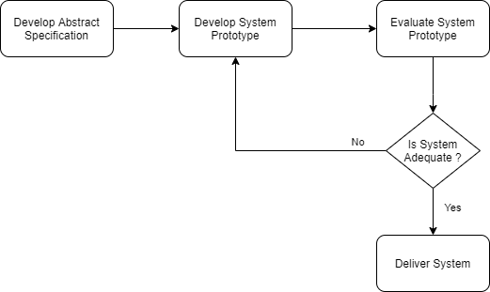evolutionary prototyping methodology was selected as the preferred approach to be used in this project after considering its own set of pros and cons.

**Figure 3.1: Phases of Evolutionary Prototyping (Shao, P. and Dida, M., 2020)**

However, a quick search online reveals that the phases involved in the evolutionary prototyping approach differs from one researcher to another. More specifically, each researcher and website online tend to have a different diagram being used to describe the said approach. Upon closer analysis, it was found that although the diagrams differ from one another, the process involved throughout the entire methodology is still relatively similar to each other. Figure 3.1 above indicates the overall flow of the evolutionary prototyping, with the details of each phase to be defined in the following sections of the report.

### **Develop Abstract Specification**

Developing the abstract specification can also be considered as the process of performing requirements elicitation and analysis, which attempts to define what a system should and should not do. During this phase, the requirements are gathered through a quantitative approach which focuses on accomplishing the project’s objectives. In this project, literature review on the currently available applications that are related to the real estate industry will be analysed to extract the key and necessary features that will be integrated into the application. Aside from the general features, additional functionalities that could further improve the existing applications will be proposed.

Secondly, surveys will be conducted by distributing questionnaires virtually to obtain the perceptions of stakeholders in the real estate industry regarding the development of a property listing mobile application. The scope of the questions being asked and analysed will revolve the features and functionalities of the property listing application to-be-developed. Past academic research will also be analysed to determine how their questionnaires are structured to avoid missing out on questions that are vital to the requirements elicitation of the project. Surveys might be able to provide additional insight from the respondents that are useful to revise the initial requirements.

### **Develop System Prototype**

This phase mainly focuses software building activities that develops the system’s prototype through iterative designing, building, testing and refining after obtaining feedbacks from end users upon evaluation. Generally, this entire phase is feature-driven in a sense that changes will be made continuously and revisited until a final prototype is approved by the end users, which in this case is the project’s supervisor. The developing of the system prototype can be further broken down into 2 distinct phases, one of which requires codes to be written while the other does not.

The design of the system should reflect the requirements that were collected during the previous phases, which in this case is the development of the abstract specification. The initial prototype will be designed using Axure RP. This is because Axure RP offers a set of drag and drop placement tools, resizing and a variety of widgets that allow both low-fidelity and high-fidelity prototype to be designed rapidly without requiring any code to be written. Furthermore, the user interface can also be redesigned and restructured easily to enable developers to experiment more on which layout offers a better user experience. A storyboard is then drawn to illustrate the links and flows between each screen in order to provide a clear overview on the overall system.

Once the low-fidelity prototype is approved by the supervisor of this project, the second and subsequent iterations can be conducted, which is developing the application using React Native.

During the second and subsequent development iterations, the prototype design from the previous iteration will be transformed into programming codes and logics. Similar process and workflow will also take place during this stage in which the emulated application will be presented to the supervisor of this project to allow them to evaluate the prototype. Upon the completion of each evaluation process, feedbacks can be provided which is then transformed into additional project’s requirements. The process of making enhancements and adding new features will be performed iteratively until a satisfactory end product is accepted by the supervisor.

### **Evaluate System Prototype**

As mentioned briefly in the previous section, the evaluation of the system prototype is done by the supervisor of this project. This process can be performed as many times as necessary until a satisfactory end product is produced and approved by the supervisor. Throughout the entire iteration, question can be asked regarding how easy the prototype was to use, ways to improve the current prototype, areas where the end user likes and dislikes as well as the suitability to be applied within the targeted domain.

After each round of evaluation has been completed, the current prototype would not be discarded as evolutionary prototyping emphasizes that the prototype is to be developed incrementally by adding new features on top of the existing ones in which will be carried over until the deployed step of the project.

### **Deliver System**

Evolutionary prototyping concludes when the end user accepts a prototype and the final end product will be delivered. Generally, this final product will be an enhanced version that consists of previously integrated features and functionalities that meets the end user’s expectations. Before deploying the system, a user acceptance testing will be performed to ensure that all the existing test case passes without any issues and provides the developers with confidence in the developed system.

Once that has been performed, the project will be properly documented to allow future maintenance and enhancement work to be accomplished with minimal effort. This form of documentation will be presented together with the final report of this project, which aims to highlight all the important and necessary details of the newly developed system.

## **Development Tools**

Throughout the entire software development process, various tools are required to be used to facilitate the entire workflow. Thus, this sub-chapter provides a brief explanation for each of the tools used.

### **Git, GitHub and Git Bash**

Git is a free and open-sourced distributed version control system that is used to facilitate the tracking of changes throughout the entire project folder. As the evolutionary prototyping methodology that has been adopted for this project is susceptible to constant changes, a proper version control handling must be carried out to mitigate the risk of breaking the entire application due to a faulty change. Should a defect were to occur, developers could roll back the changes to a previous commit that is working in a previous version.

Source codes can be committed to GitHub through the Git Bash command window. By committing changes to GitHub’s repositories, developers will be able to retrieve their updated project files in case of a hard drive failure were to occur without any issue.

### **Visual Studio Code**

Microsoft’s Visual Studio Code, or VS Code for short is the preferred integrated development environment (IDE) throughout the development life cycle of this project. The main reason that this IDE was selected is because it offers an integrated source code management (SCM) that supports Git, which enables code changes to be tracked as compared to its previous commit almost immediately as shown in Figure 3.2 below.

Moreover, Visual Studio Code also offers a wide variety of extensions that can be installed according to the developer’s preferences. One example that can be seen is by installing the Prettier code formatter, this allows indentation and formatting of the source codes to be done automatically by the IDE itself without needing the developers to do it manually. This enforces a consistent styling that enables the project to be properly documented in a more readable format.

In addition, other features that enables developers to benefit from choosing Visual Studio Code as the IDE is its IntelliSense code completion, rich semantic code understanding and navigation as well as code refactoring (Visual Studio Code, n.d.).

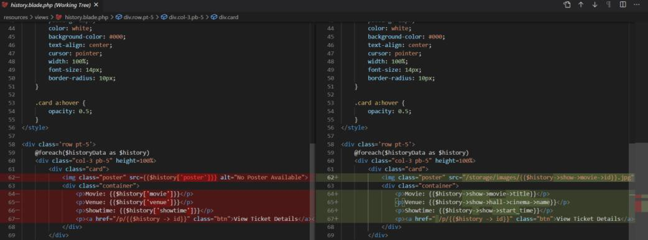

Figure 3.2: Visual Studio Code Source Control

### **Axure RP**

As mentioned briefly in the previous section, Axure RP is a simple yet powerful prototyping tool that offers a set of drag and drop placement tools, resizing and a variety of widgets that allow both low-fidelity and high-fidelity prototype to be designed rapidly without requiring any code to be written. Axure RP also offers a temporary license for university students to utilize the software, which is perfect in minimizing the costs required to design and develop the application as part of this project.

Furthermore, the user interface can also be redesigned and restructured easily to enable developers to experiment more on which layout offers a better user experience. Once the individual screens of the prototype is crafted, a storyboard will then be drawn to illustrate the links and flows between each screen in order to provide a clear overview on the overall system. Once the low-fidelity prototype is approved by the supervisor of this project, the second iteration can be conducted, which is developing the application using React Native.

### **Android Studio**

Despite already having selected VS Code as the preferred IDE to be used throughout the implementation phase of this project, Android Studio, which is also an IDE will be used alongside VS Code. However, the main purpose of selecting Android Studio as part of the development tools is because it offers an Android Virtual Device to emulate the environment of a real mobile device within the computer.

By using the emulator to simulate Android devices on a local computer, the applications under development can be tested without requiring the need to own a physical device. This will speed up the development process as developers will be able to detect any potential issues while the application is actively running in the emulator and implement the fixes accordingly.

### **React Native Framework**

As mentioned in Chapter 2, which discussed the comparison between native and cross-platform applications, React Native framework was selected to be the main approach for developing the property listing application.

React Native is an open-sourced framework that offers a swift and smooth way of developing mobile applications with responsive user interfaces along with a decrease in the time taken to boot the application. Not only that, but it also offers various components, dependencies and application programming interfaces (API) that is developed and actively maintained by its community. In addition, React Native also enables the incorporation of third-party plug-ins and APIs that could be integrated easily and enable developers to utilize them. Since the property listing application emphasizes the need to display available properties on a Google Map interface instead of the traditional list view, an API associated with maps can be installed and imported with ease.

While it can be said that the React Native framework has its drawbacks and other options such as the Ionic framework or Flutter might be a better option, the main deciding factor is that it all comes down to the developer’s preference, as each framework has their own set of advantages and disadvantages. Due to the past experience and expertise in the developers involved in this project has with React Native, this framework is selected as it does not require the learning of another language for the purpose of developing this property listing application.

### **Google’s Firebase**

Google’s Firebase was selected to be the back-end database for this project, specifically Firebase Cloud Firestore and Firebase Storage. The main reason that Firebase was chosen is because it contains its own set of APIs that functions well with React Native. In addition, the communication channels between the front-end and the back-end of the application can be made just with a simple line of code to utilize the APIs.

As the property listing application contains an integrated chat feature, developers that chose Firebase would benefit their development process as it contains an API that enables the integration of online chat functionality with minimal complexity.

With just a little bit of configuration, which was also properly documented with clear feedback and next steps, developers are able to handle all of the application’s backend requirements. This includes user authentication, storing data, real-time event listeners and configuring access rules.

## **Analysis Models**

Analysis models is a technical representation of the system. It acts as a link between the system description and the design model. In Analysis Modelling, information, behavior, and functions of the system are defined and translated into the architecture, component, and interface level design in the design modelling.

### **Use Case Diagram**

Use-case diagrams **describe the high-level functions and scope of a system**. These diagrams also identify the interactions between the system and its actors. The use cases and actors in use-case diagrams describe what the system does and how the actors use it, but not how the system operates internally.

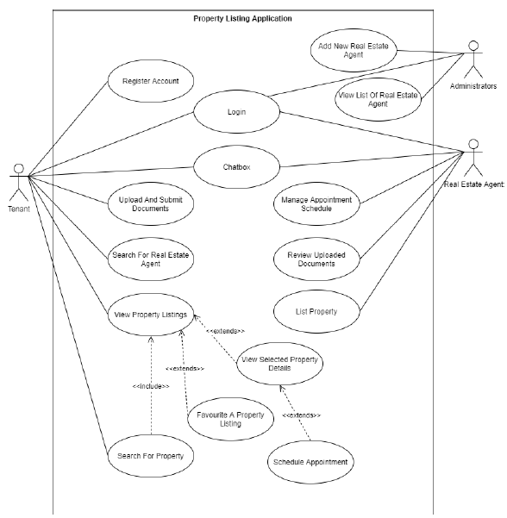

**Figure 3.1: Use Case Diagram**

### **ER Diagram**

An entity-relationship diagram (ERD) shows the relationships of entity sets stored in a database. An entity in this context is an object, a component of data. An entity set is a collection of similar entities. These entities can have attributes that define its properties.



**Figure 3.2: ER Diagram**

### **Sequence Diagram**

Sequence Diagrams are interaction diagrams that detail how operations are carried out. They capture the interaction between objects in the context of a collaboration.

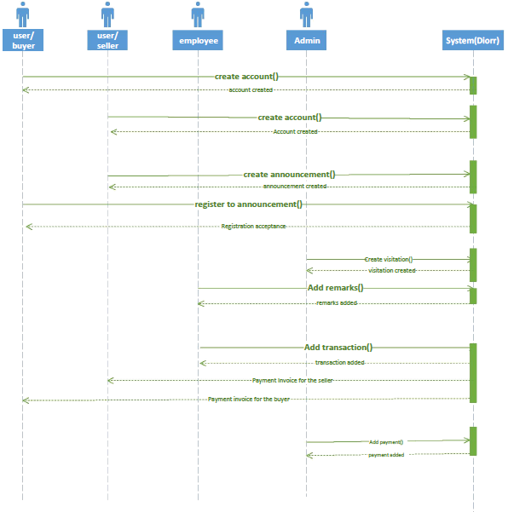

**Figure 3.3: Sequence Diagram**

**REFERENCES**

Adarsh, S., Harish, D., Balaganapathy, K., Venkatachalapaty, R., Abishiek, E. and Nagarajan, M., (2017). Improved software quality and design standards based on customer preferences by applying evolutionary prototyping software development model. International Journal of New Technology and Research, [online] Available at: <https://media.neliti.com/media/publications/263299- improved-software-quality-and-design-sta-e26d12d9.pdf> [Accessed 26 December 2021].

Agustiono, W., (2018). Applying Evolutionary Prototyping in Developing LMIS: A Spatial Web-Based System for Land Management. Journal of Physics: Conference Series, [e-journal] 953(1).<http://dx.doi.org/10.1088/1742-6596/953/1/012147.>

Andrei, B., Casu-Pop, A., Gheorghe, S. and Boiangiu, C., (2019). A study on using waterfall and agile methods in software project management. Journal of Information Systems & Operations Management, [online] Available at: <<http://jisom.rau.ro/Vol.13%20No.1%20-%202019/JISOM-SU19-A12.pdf>> [Accessed 23 December 2021].

Asri, S.A., Astawa, I.N.G.A., Sunaya, I.G.A.M., Yasa, K.A., Indrayana, I.N.E. and Setiawan, W., (2020). Implementation of prototyping method on smart village application. Journal of Physics: Conference Series, [online] 1569, pp.1-6. http://dx.doi.org/10.1088/1742-6596/1569/3/032094.

Baryla, E. and Ztanpano, L., (2020). Buyer search duration in the residential real estate market: the role of the real estate agent. Journal of Real Estate Research, [e-journal] 10(1), pp.1 - 13. https://doi.org/10.1080/10835547.1995.12090769.

Biørn-Hansen, A., Grønli, T., Ghinea, G. and Alouneh, S., (2019). An empirical study of cross-platform mobile development in industry. Wireless Communications and Mobile Computing, [e-journal] 2019. https://doi.org/10.1155/2019/5743892.

Casteren, W. V., (2017). The waterfall model and the agile methodologies: a comparison by project characteristics. [e-journal]. https://doi.org/10.13140/rg.2.2.10021.50403.

Chari, K. and Agrawal, M., (2017). Impact of incorrect and new requirements on waterfall software project outcomes. Empirical Software Engineering, [e- journal] 23, pp.165-185. https://doi.org/10.1007/s10664-017-9506-4.

Department of Statistics Malaysia, (2021). Current Population Estimates, Malaysia, 2021. Malaysia: Department of Statistics Malaysia.

Dewaele, J., M., (2018). Online Questionnaires. In: A. Phakiti, P. De Costa, L. Plonsky, S. Starfield ed. 2018. The Palgrave Handbook of Applied Linguistics Research Methodology. London: Palgrave Macmillan. pp. 269-286.

Felli, F., Liu, C., Ullah, F. and Sepasgozar, S.M.E., (2018). Implementation of 360 videos and mobile laser measurement technologies for immersive visualisation of real estate & properties. In: AUBEA (Australasian Universities Building Education Association), 42nd AUBEA Conference 2018 on educating building professionals for the future in the globalised world. New South Wales, Australia, 26-28 September. New South Wales, Australia.

Franklin, S., (2020). Real estate transactions go virtual. [online] Available at: <[https://www.nytimes.com/2020/11/11/re](http://www.nytimes.com/2020/11/11/realestate/10virtual-deals.html)a[lestate/10virtual-deals.html](http://www.nytimes.com/2020/11/11/realestate/10virtual-deals.html)> [Accessed 26 February 2021].

Georgiou, M., (2019). 13 Must-Have Features that Make a Winning Real Estate App in 2020. [online] Available at: <[https://www.im](http://www.imaginovation.net/blog/must-have-real-estate-app-features/)a[ginovation.net/blog/must-have-real-estate-app-features/](http://www.imaginovation.net/blog/must-have-real-estate-app-features/)> [Accessed 23 December 2021].

Guru99, n.d. Prototyping Model in Software Engineering: Methodology, Process, Approach. [online] Available at: [<https://www.guru99.com/softw](http://www.guru99.com/software-)a[re-](http://www.guru99.com/software-) engineering-prototyping-model.html#3> [Accessed 24 December 2021].

Hayat, F., Rehman, A., U., Arif, K., S., Wahab, K. and Abbas M., (2019). The Influence of Agile Methodology (Scrum) on Software Project Management, 20th IEEE/ACIS International Conference on Software Engineering, Artificial Intelligence, Networking and Parallel/Distributed Computing (SNPD). Toyama, Japan, 8-11 July 2019. New York: IEEE.

Huber., S. and Demetz., L., (2019). Performance analysis of mobile cross- platform Development approaches based on typical ui interactions. In: ICSOFT (International Conference on Software Technologies), Proceedings of the 14th International Conference on Software Technologies. Prague, Czech Republic, 26-28 July 2019. New York: Springer.